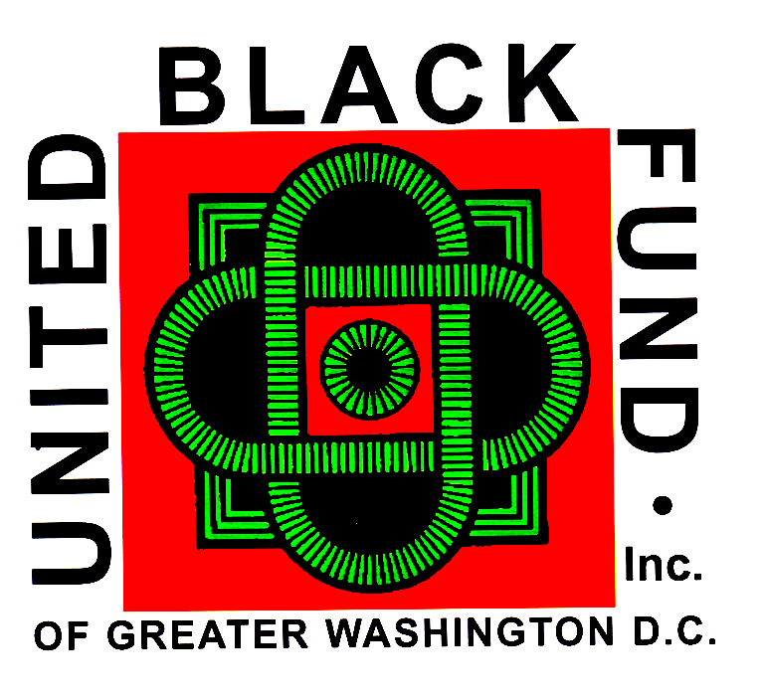

**Principal Office**  [**unitedblackfund@ubfinc.org**](mailto:unitedblackfund@ubfinc.org) **UBF TrainingCenter**

**412 H Street, NE. 3855 Livingston Road**

**Washington, D.C. 20002 Indian Head, MD, 20640**

**(202) 783-9300 (240) 377-8505**

**Dr. Calvin W. Rolark, Sr.**

**President Emeritus**

**Wilhelmina J. Rolark, Esq.**

**President Emeritus**

**Johnnie Scott-Rice**

**Chair**

**Barry LeNoir**

**President**

***United Black Fund, Inc. MEMBERSHIP AFFILIATION FORM***

**Organization Name: ______________________________________**

**The above-named organization hereby seeks to affiliate with the United Black Fund of Greater Washington, as a member for the UNITED BLACK FUND FEDERATION OF CHARITIES for participation in the Combined Federal Campaign, the District of Columbia One Fund Campaign, the Maryland Charity Campaign, or other FUNDRAISING CAMPAIGNS FOR WHICH WE ARE ELEGIBLE. We agree that on our behalf, the United Black Fund will:**

* **Screen our application in accordance with the eligibility requirements of the CFC as published by the U.S. Office of Personnel Management (OPM) or other Administering Authority, filing the completed application with the Administering Authority if it is deemed it to be eligible. The final determination of our organization’s eligibility will be made by the Administering Authority of the respective Campaign;**
* **Report to us in writing the amount of money that has been pledged to our organization in the Campaign projecting the amount we can reasonably expect to receive after local CFC administrative costs, donor non-fulfillment, and the United Black Fund fee (see below) are considered;**
* **Forward to us the names and contact information of those donors who ask to be acknowledged by our organization;**
* **Forward to us donated funds that are received on behalf of our organization by the United Black Fund from the Campaign minus any United Black Fund fee. The United Black Fund asks members to contribute to the cost of screening applications, reporting pledges, distributing funds, and other Campaign related activity. The fee to be paid by any organization reflects that organization's net receipts in the Campaign. The Fee is set Annually.**

**I certify by my signature below that I have read the United Black Fund Affiliation Form and that the information I provided is true.**

***ORGANIZATION _____________________________________________________________; EIN NUMBER: ______________________***

***ADDRESS: _____________________________________________________________________________________________________***

***CITY: ____________________________________________________; STATE: __________________________; ZIP: ______________***

***PHONE: _____________________________; EMAIL: __________________________________________________________________***

***Print or Type Name*: ____________________________________________ *Title: _______________________________________***

***Certifying Signature _________*____________________________________ Date*: ______________________________________***